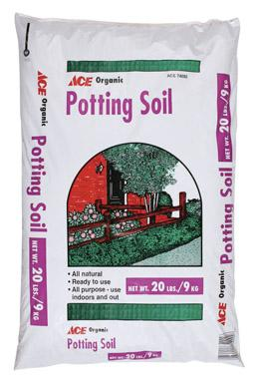
Ace
Potting Soil
- 1 Cubic Foot
- Ready to Use
#13

- For indoor and Outdoor

$3.99
7208705

